### **ECNS 560 Term Project**

#### **The Impact of Rice Price Fluctuations on Household Size and Child Dependency Ratios in Bangladesh (1991-2011)**

By **Saimun Nahar Saki**

### **Research Question:**

How do rice price fluctuations impact household size and child dependency ratios in Bangladesh? Do these effects differ between rural and urban households over time (1991-2011)?

### **Key Variables:**

**Independent Variable:**

* Rice price fluctuations (1991-2011)

**Dependent Variables:**

* Household size (Total number of individuals in a household)
* Child dependency ratio (CDR) CDR=Number of Children 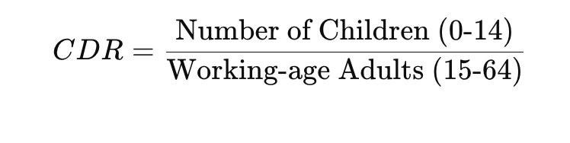

**Control Variables:**

* Urban vs. Rural household (URBAN)
* Household employment status (EMPSTAT)
* Household educational level (EDUCBD)
* Labor force participation (LABFORCE)
* Parental education level (YRSCHOOL)

### 

### 

### **Motivation:**

This project is particularly interesting to me because rice is not just a staple food in Bangladesh—it is a lifeline for millions of households, especially those living in poverty. When rice prices rise, families are forced to make difficult choices: some may take in more relatives to share costs, while others may struggle to afford education for their children.

I want to explore how these price fluctuations shape household structures over time. Do families expand during economic hardships? Are children more likely to drop out of school when rice becomes too expensive? Does this impact rural and urban households differently?

By analyzing household data from 1991, 2001, and 2011 alongside rice price trends, I aim to uncover how economic pressures drive changes in family size and dependency ratios. This research will help us understand the long-term social effects of food price shocks, contributing to discussions on economic stability, food security, and social policy in Bangladesh.

### **Data Sources:**

**Rice Price Data (1991-2011) – FAOSTAT & National Trade Data**

* Monthly and annual rice prices

**Household Data – IPUMS Bangladesh (1991, 2001, 2011)**

* Household size, number of children, employment, education
* Urban vs. rural classification
* Socioeconomic conditions (household work, parental education)

### **Unit of Observation:**

* **Household-level data** across multiple years (1991, 2001, 2011)
* **Yearly time-series data** for rice prices